
TDAmeritrade
Solution Definition

Managed File Transfer Project

Authors:
Sterling Commerce
Date Created: 04 Nov 2008
Last Updated: 04 Feb 2026
Version: 1.0
File Name: 0000.doc

Document Revision History
Revision | Date | Description (Changes Made) | Author
0.1 | 04 Nov 2008 | Document creation | Ian Montgomery
1.0 | 14 Nov 2008 | Document revision | Ian Montgomery
Document Approval History
Name | Signature | Date | Version Approved / Comments
Related or Reference Documents
Document Name | Description | Owner | Location

TABLE OF CONTENTS

1. Introduction 5
1.1 Document Purpose 5
1.2 Document Audience 5
1.3 Document Layout 5
2. Executive Summary 6
3. Architecture Overview 7
3.1 System Context and Overview 7
3.2 Major Subsystems 8
3.2.1 Client/Presentation Tier 8
3.2.2 DMZ Tier 8
3.2.3 Application Tier 8
3.2.4 Data Tier 11
3.3 Architectural Goals and Constraints 11
3.3.1 Goals 11
3.3.2 Constraints 11
3.3.3 Integration Requirements 12
4. Technical Requirements 12
4.1 Availability 12
4.2 Reliability and Accuracy 12
4.3 Security 13
4.3.1 Users and User Groups 13
4.3.2 External Authentication 13
4.3.3 Data Access Security 13
4.3.4 Data-at-Rest 13
4.4 Performance and Scalability 13
4.5 Database Services 14
4.6 Integration Services 15
5. Logical Architecture 15
5.1 Overall Logical Architecture 15
5.1.1 Internal File Transfers 16
5.1.2 External File Transfers 17
5.1.3 Client Tier - Presentation Layer Logical Architecture 17
5.1.4 DMZ Tier – Transportation Layer Logical Architecture 18
5.1.5 Application Tier - Business Services Layer Logical Architecture 18
5.1.6 Data Tier – Data Storage Layer Logical Architecture 23
6. Physical Architecture 24
6.1 System Physical Architecture 24
6.1.1 ITE (Test/Dev) environment: 26
6.1.2 Perimeter Services 27
6.2 Disaster Recovery System Physical Architecture 28
7. Process Architecture 29
7.1 Solution Definition 29
7.1.1 Participant Model 29
7.1.2 Capacity Management 29
7.1.3 Business Process Model 29
7.1.4 Naming Standards 32
7.1.5 Archive Strategy and Access 32
8. Requirements 32
8.1 Business Requirements 32
8.1.1 Notification 32
8.1.2 Priority file processing 33
8.2 Functional Requirements 33
8.2.1 Protocols 33
8.3 Non-Functional Requirements 33
8.3.1 Infrastructure 33
8.3.2 Logging/Notification 34
9. Training Plan 34
10. Open Items 35
10.1 Infrastructure 35

Introduction

Document Purpose
The purpose of this document is to serve as the governing architecture document for the project. All design and implementation is done according to architectural constructs specified in this document. The document contains key technical decisions taken on the project. It also documents how technical requirements such as availability, performance, and security are being met.

Document Audience
This document is the governing architecture document for the project. It presents significant decisions and constructs used in developing the solution for the Data Feed Implementation. While the document serves as the overall architecture guide, it is not a detailed design document. In addition, testing, builds, configuration management are not covered in this document.

This document is intended for management and technical staff working on this project.

Document Layout
The document starts with an overall conceptual view of the architecture and presents some of the architectural challenges that need to be met. The next part of the document presents some of the core constructs used in each tier of the n-tier architecture. Following this, the different views of the architecture implementation are presented:

- The logical view
- Process View
- Physical View

Executive Summary
The TDAmeritrade managed file transfer project seeks to consolidate internal and external file transfer protocols to a single platform. Using Gentran Integration Suite (GIS) from Sterling Commerce TDAmeritrade gains this capability as well as simplified file transfer management, improved visibility, centralized administration, and high-availability among others.

GIS is an integration framework supporting a number of common communications protocols including those that are Sterling Commerce proprietary. Using GIS allows TDAmeritrade to present all the common communications protocols to their current vendors with minimal changes, but with increased value-add functionality such as myFile Gateway portal.

File Gateway is part of the GIS framework providing advanced file transfer functionality and ease of on-boarding of new vendors. File Gateway is a high-performance file transfer application using a mailbox paradigm to simplify the transition from traditional communications servers such as FTP. It allows for centralized management and administration of all the protocols used by TDAmeritrade.

Sterling Control Center (SCC) is an application that monitors Sterling Commerce application servers and provides alerting and reporting to the operations group.

Through the use of these Sterling Commerce products TDAmeritrade is able to better manage and improve their file transfer cababilities.

Architecture Overview
This section documents the architectural patterns and best practices followed in the overall system. The section gives a high-level overview of the architecture and describes the major subsystems.

System Context and Overview
The Gentran Integration Suite framework is designed according to the principals of n-tiered architecture. The following diagram illustrates the composition of a general n-tiered architecture. Each tier of the system is a distinct physical collection of application services and functionality.

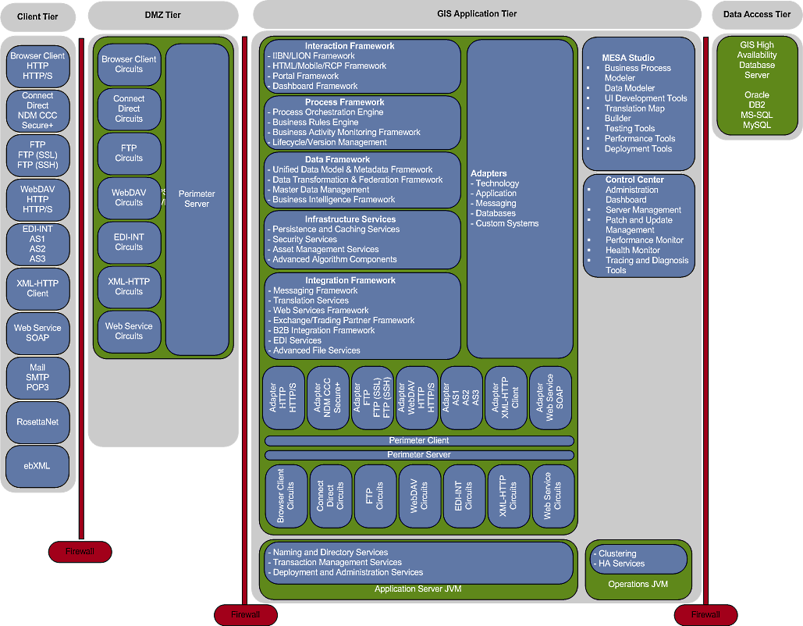

The diagram above depicts the overall system, which is broken up into the major tiers and sub-systems. These subsystems are described in detail later in this document.

Major Subsystems

Client/Presentation Tier
All components in the Presentation Tier are external applications acting as clients of GIS. These interfaces allow personnel or external systems to interact or interface with GIS. Examples of Presentation Tier clients are listed below.

Browser Client
The web browser client application presents the user interface for all externally accessible GIS web applications. It employs a combination of HTML, graphic content, Java and JavaScript to display various user interfaces (UI) including the administration console dashboard as well as customer-facing GIS components.

Through the use of a browser, clients have the ability to interact directly with GIS using the Mailbox Interface (MBI) hosted by GIS giving them visibility to their data as it exists in their FTP directory structure. Additionally, the MyFile Gateway UI presents a dashboard that visually indicates route status as well as links to detailed information about the routes.

FTP Server
The FTP Server within GIS presents FTP clients with a reduced function set FTP server for file transfer. It allows clients to use a variety of FTP clients including command-line or graphical applications. Additionally, GIS hosts an HTTP-based mailbox interface that allows file transfer through the browser. Supported protocols include FTP, FTPS (SSL), and SFTP (SSH).

WebDAV
The Web Distributed Authoring and Versioning (WebDAV) protocol is a standard extension to the HTTP/1.1 protocol that allows data to be written directly to WebDAV servers through a browser. The browser client connects to the GIS WebDAV URI for data file transfers. The browser then acts similar to the Windows File Explorer paradigm where files are dragged and dropped or copy-and-pasted from one “folder” to another.

Mail
GIS uses SMTP standards for sending emails. Emails are used to notify internal and external personnel. GIS is capable of retrieving email from POP3-enabled mailboxes.

DMZ Tier
The DMZ Tier is not part of this implementation; all communications are internal between applications.

Application Tier
All business logic, data storage management, and security credentials are implemented in the Application Tier. GIS uses at least two JVMs for each instance: GIS JVM and the Operations Controller JVM. An additional JVM is used when a third-party Java Application Server is used to manage GIS. Other JVMs are needed when the implementation includes Perimeter Server(s), Command Line Adapters, or other stand-alone adapters.

Operations Controller JVM
The Operations Controller provides services for the following features.

Adapter status

Clustering Services

High Availability Services

GIS JVM
The GIS JVM is the main Application that consists of the following functional layers:

Internal Perimeter Server
The “local” Perimeter Server is included during routine installation of GIS and provides IP-protocol adapter support within the trusted zone. This local PS provides presentation of the GIS user interface as well as other services.

Internal Perimeter Client
The internal Perimeter Client allows GIS Client protocol adapters to communicate with IP protocols presented by internal servers.

External Perimeter Client
The external Perimeter Client allows GIS Client protocol adapters to communicate with IP protocols presented by external servers.

Communications Adapters
Communication Adapters handle specific communication protocols in either a Server or Client configuration. These adapters are then used to provide communication services within a process flow. The adapters are individually configured to communicate through the local or external perimeter servers.

Integration Framework
Integration Framework controls all the interaction with external components or systems.

Operations Control (Client)
Operations Control is provided by the Administration Browser based GUI.

Administration Dashboard

Server Management

Patch and Update Management

Performance Monitor

System Statistics Monitor

Tracing and Diagnostics Tools

Translation Services
Translation Services control data transformation within GIS. Some transformations are handled by XML transformation services such as XSLT.

The exact transformation to MES is unknown at this time. It is likely going to be the current flat-file structure. Standard GIS translation services and maps are used to provide this functionality.

File Gateway Services
Sterling File Gateway Services handle automated data file transfers making use of a Business Rules Engine, Mailboxes, Business Processes and various communications adapters.

Infrastructure Framework
Infrastructure Framework controls all the services and adapters within GIS.

Persistence and Caching Services
Persistence and Caching Services are used for all database Pools, services, adapters and business processes.

Security Services
Security Services control all authorization, authentication and user privileges within GIS.
- Internal GIS User ID and passwords
- Storage of Certificates
  - CA Certificates
  - Trusted Certificates
  - System Certificates
- Linkage of certificates to User, Adapters and Communication protocols

Data Framework
Data Framework controls the way GIS views specific data within the system. Depending on the Modules and usage, identification of and location of the business’s “data of record” within an organization is one of its key functions.

Process Framework
Process Framework controls all activities within GIS.

Process Orchestration Engine
Process Orchestration Engine is used to coordinate all Business Processes, Services, and Adapters used in this solution.

Business Rules Engine
Business Rule Engine controls the logic of business rules within GIS. This architecture makes use of the File Gateway Business Rules Engine.

Lifecycle/Version Management
Lifecycle/Version Management controls version of Business Processes and other assets within GIS. This project makes use of this for Business Processes, transformation maps, and code lists used in this solution.

Portal Framework
Portal Framework provides the services for portals such as the Administrator and Operator dashboards/portals.

Dashboard Framework
Dashboard Framework provides the services for dashboards. This project makes use of the Administrative dashboard and the Participants File Gateway dashboard.

Adapters
Adapters are GIS services that communicate with external systems. They send and receive data between GIS and the given system.

Application Adapters
Application adapters provide application interface functionality to GIS. Typically application libraries must be provided by the application vendor for GIS to directly interface with the app.

Messaging Adapters
Messaging Adapters in GIS specifically handle the interaction between GIS and messaging protocol standards. All drivers are J2EE based and include the functionality for a specific protocol.

Database Adapters
Database adapters in GIS specifically handle the interaction between GIS and a target database application. All drivers are Level IV JDBC compliant and include multiple layers of caching within GIS and/or the database application.

Data Tier

The Data Tier is the default primary location for storage of all information within the GIS framework. In the modern enterprise, this data is stored in an enterprise database management system, by a legacy or mainframe system, or in some unknown location abstracted behind a messaging transport or web service. Regardless of where data is stored or how it is used outside the application in the enterprise, APIs in the Data Tier are invoked by mechanisms in the Application Tier to retrieve it for use by the application or to store it external to the application for later use. Fundamentally, this logical tier represents the application’s data interface to the outside world.

Architectural Goals and Constraints
The solution is provided within the goals and constraints identified.

Goals
Primary goals for this project include:
- Use of GIS as the communications protocol hub for both internal and external file transfer
- Use of Sterling Control Center to provide monitoring of GIS instances and alerting
- Use of Sterling File Gateway to provide configuration-based (filename-based) message routing
- Rapid processing of high-volume message traffic
- High-availability environment
- LDAP external authentication
- SNMP traps for console-based alerting
- Direct support of FTP, FTPS, HTTPS, and Connect:Direct (NDM) protocols
- Migrate all internal FTP communications to GIS
- Migrate all internal FTP communications in GIS to Connect:Direct as time permits
- Migrate all Vendor communications to GIS while increasing use of NDM with Vendors

Constraints
Gentran Integration Suite (GIS)
- SUSE Linux 9
- Oracle 10g (10.2.0.4)
- File System document storage
- Encrypted documents at rest

Sterling Control Center (SCC)
- Co-located on GIS Node 1 server
- SUSE Linux 9
- Oracle 10g (10.2.0.4)

Integration Requirements

Gentran Integration Suite (GIS)
- Data Producers (internal and external) transfer files with GIS File Gateway using the following protocols:
  - FTP (90%)
  - FTPS (4%)
  - Connect:Direct (NDM) (1%)

- Data consumers are configured to listen for data using the following protocols:
  - FTP (90%)
  - FTPS (4%)
  - Connect:Direct (NDM) (1%)

- GIS uses the File System Adapter for collecting application data being sent to consumer endpoints.

- Consumers and Producers can monitor the success/failure of all data that pertains to the specifically assigned Consumer or Producer only seeing data that belongs to them.

Sterling Control Center (SCC)
- Monitors and collects transfer processing statistics from GIS servers.

- Monitors real-time processing status from GIS servers.

- Sends notifications/alerts via SMTP (email) as well as SNMP traps.

Technical Requirements

Availability
High-availability (HA) is critical in a global architecture standard. TDAmeritrade requires a high-availability environment. Minimally a two-node cluster provides a highly-available enterprise framework for message transfer. The GIS environment at TDAmeritrade meets the HA configuration at the network and application architecture level once implemented. All GIS business process and adapter configurations take High-Availability into account.

Reliability and Accuracy
Reliability defines the acceptable stoppage of data. Given the High-Availability architecture of the GIS application cluster and the ability to be highly multi-threaded reliability is improved over previous application approaches.

Accuracy defines expectations for the correctness of data, calculations and/or transactions. Thorough testing of end-to-end process flow traversal validates both reliability and data quality. This implementation requires no data manipulation and is strictly limited to data movement. Accuracy of data is potentially affected by the use of compression and/or cryptography services within the lifetime of a given document. Only through thorough testing of the end-to-end process can data quality issues be identified or dismissed.

Security
TDAmeritrade identifies the use of LDAP for external authentication and various cryptography methods for data security. Where the vendor is capable of using a secure file transfer protocol it must be used.

Users and User Groups
Gentran Integration Suite requires system passwords for administrative functions and uses role-based security to provide different levels of access to different users within the organization.

Role-based security provides access to certain files, business processes, Web templates, services, and product features, according to the permissions associated with the user account.

A user account contains the groups the user belongs to, the permissions associated with each group or user, and the password policy applied to the user. Groups are collections of permissions and other groups that are required by a user for access to different modules. Permissions provide access to the different modules within Gentran Integration Suite and are the foundation of role-based security. Password policies allow rules-based password creation requirements and expiration settings.

Groups make it possible to maintain access permissions for several users from a single place. Groups help minimize the amount of work involved with maintaining accounts, especially when several users perform the same job function. Many permissions may be assigned to different users by creating groups for each job function instead of each user. Adding a user to a specific group gives that user the permissions associated with that group. Multiple groups may be assigned to a user. Groups are allowed to contain subgroups.

External Authentication
GIS may leverage LDAP services for authentication of user accounts. This provides simplified user account maintenance and password policies in the enterprise.

Data Access Security
File Gateway users are not allowed access to any data that does not belong to them. Mailbox access is controlled through the use of a virtual root concept that ties a user account to a mailbox. If that mailbox contains sub-mailboxes access is also granted to those. Only the mailbox administrator accounts have control over all mailboxes.

Data-at-Rest
Data-at-rest must be encrypted. The GIS configuration must be set to encrypt data-at-rest.

Performance and Scalability
The system must adequately handle expected volumes within expected timeframes. Volume is typically measured in the number or users or transactions processed in a finite amount of time (per second, minute, hour, day, etc). In addition to average volume, peak volumes must be anticipated and processed within acceptable frames, usually at different rates than average volumes.

In terms of scalability, the system must support expansion in two key areas:
- In response to gradual increases in overall volume over time (i.e. – the system design must allow for growth to accommodate anticipated traffic increases without sacrificing performance)
- In response to sudden, unexpected increases in volume (i.e. – ensuring that the system suffers little to no reduction in performance due to the increased volume)

TDAmeritrade requires aggressive message processing performance. There are no real Service Level Agreements (SLA), but performance requirements are implied by the volume of data traversing GIS. Production level volumes indicated 12,000 unique messages per day. File volume estimates range from 600Gb to 2Tb per day. Individual file sizes range from 200kb to 50Gb.

TDAmeritrade projected volume:
- 12,000 unique files per day
- File size range is 200Kb to 50Gb
- 600Gb to 2Tb document volume per day
- 130 Vendors
- 100s of internal endpoints

There are peak volume times between the end of the month and the first day or two of the following month. Additional peaks volumes occur at quarter end.

A minor risk is identified here strictly from the wide ranging document volume figures. The general consensus was to error on the side of caution and go with the larger values.

Database Services
The database services layer isolates application developers from the intricacies of database development and implementation. It controls the low-level mechanisms to access and update the database. It also governs the creation of database objects, and authenticates and authorizes database users. Changes to a database schema, the object models or the physical database implementation are therefore isolated from the application. Through the use of database software provider-supplied java database connectivity (JDBC) drivers GIS is able to communicate requests to the database layer.

GIS uses the database to store service and adapter configurations, producer/consumer profiles, business process metadata, digital certificates, and numerous GIS assets including the business processes themselves. Traditionally GIS uses the database to store the working documents traversing the business processes and mailboxing systems.

Due to the large data volume expected GIS is configured to use the file system storage option. This allows GIS to use the Network Attached Storage (NAS) as its document storage area. The data must be encrypted while at rest and GIS accomplishes this using the S/MIME protocol and digital certificate created and stored in the GIS system.

Database services support:
- GIS application database cluster on Oracle 10g (10.2.0.4) using the ojdbc14.zip JDBC drivers

Integration Services
GIS uses adapter services for interfacing with external applications using common IP-based protocols as well as vendor-proprietary protocols. Vendor protocols require the use of vendor-provided libraries in order to communicate with their applications.

TDAmeritrade uses standard IP-based protocols as well as the Sterling Commerce Connect:Direct protocol (aka NDM). All of the protocols identified for this implementation are directly supported by GIS and the Sterling File Gateway framework it contains.

Currently 95% of all traffic internally and externally uses FTP without encryption at the protocol-level. A majority of the files transferred via FTP are encrypted using PGP. GIS is not responsible for PGP cryptography services in this implementation. Another 4% of the file transfers occur over FTPS with the remaining 1% over Connect:Direct (C:D).

Vendors continue using the currently defined protocol after being migrated to GIS or they are migrated to Connect:Direct. Under the new architecture vendors send and receive files directly through the GIS mailboxing File Gateway system. This system appears to them as an FTP server or Connect:Direct server. Effectively their view of the file transfer is no different other than an IP/DNS address change or a port change.

Internally applications are expected to migrate to the Connect:Direct implementation for an improved security model over time. In the interim FTP is sufficient and consistent with the current model so that the majority of the internal application file transfers occur over FTP in GIS until they are migrated to the C:D protocol.

Internal file transfers that move or copy files about the network file system continue to be handled by SysAdmiral.

Integration Services used by this architecture:
- FTP (95%)
- FTPS (SSL) (4%)
- Connect:Direct (NDM) (1%)

Logical Architecture

Overall Logical Architecture

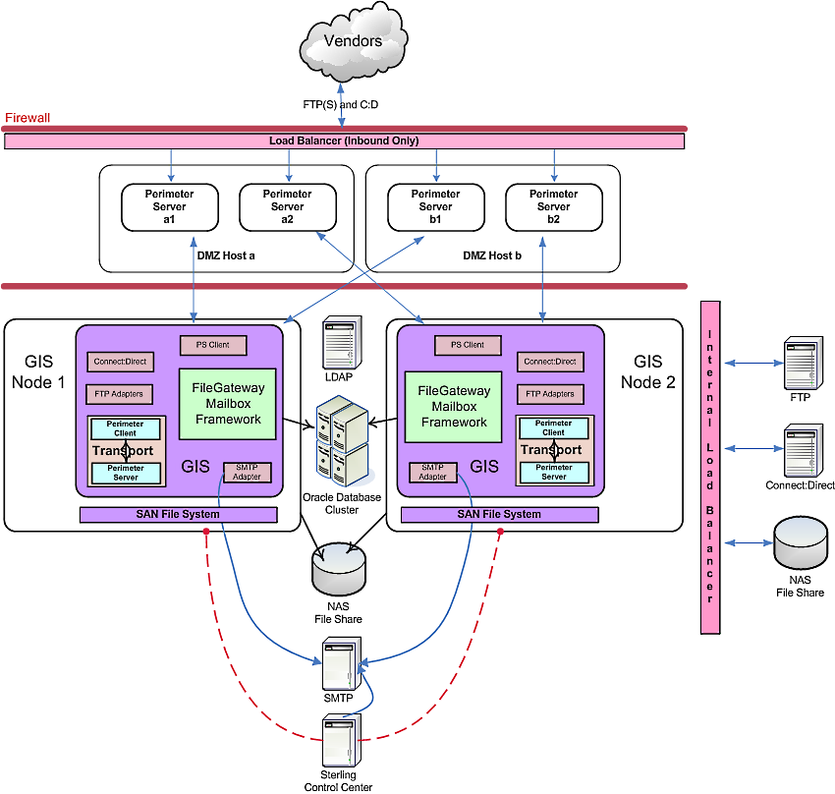

The TDAmeritrade file transfer logical architecture describes the logical flow of files through the Sterling Commerce product stack.

Files are transferred both internally and externally. Files are exchanged between applications and vendors.

Internal File Transfers

Internal documents are currently transferred using only FTP. In this implementation all file transfers are eventually migrated to Connect:Direct (NDM). Initially all transfers are established using FTP in GIS before being changed to Connect:Direct.

Internal files transfers originate as documents placed on the network file shares by the "SysAdmiral" scheduling application. SysAdmiral triggers generation of files needing transferred. The application generating the file places it in a known location with a known filename. GIS collects the files using the file system adapter and adds them to the producing applications Producer mailbox in the File Gateway framework. The Routing Channel Template determines the Routing Channel based on the filename and the consumer identification policy. Once the routing engine determines the Consumer the file is routed to the endpoint identified within the Consumer profile.

The Consumer endpoint may be another mailbox, a communications protocol, or a file system location available via NFS. Files placed in a consumer mailbox must be collected by the consumer; the files are not pushed to them.

Producers and Consumers are names given to external vendors as well as internal applications. A producer may also be a consumer.

External File Transfers

External file transfers with vendors are exchanged using FTP, FTP(S), and Connect:Direct protocols.

Outbound files originate on a network file system after being triggered by SysAdmiral. GIS collects them just the same as internal files. The file is passed to the Producer mailbox via GIS business process after being collected. The Routing Channel Template determines the Routing Channel based on the filename and the consumer identification policy. Once the routing engine determines the Consumer the file is routed to the endpoint identified within the Consumer profile.

The Consumer endpoint identified in the consumer profile is used to send the file via a communications protocol or to have the file placed in a mailbox for collection at a later time by the consumer.

Inbound files are sent to GIS by the vendors using FTP, FTPS, or Connect:Direct. The files enter the TDAmeritrade network through the GIS Perimeter Servers installed in the DMZ. The Perimeter Servers act as reverse proxies and multiplexers through which the listed protocols pass in order to make the GIS File Gateway mailbox framework available externally. All protocols end up placing files into the Producer mailbox construct where the files are processed and forwarded to a Consumer mailbox or server using a communication protocol or network file system.

Neither internal or external files need any processing, they are only transferred through GIS. All files transferred externally using FTP are sent PGP encrypted. GIS is not responsible for PGP cryptography services; this is handled by the SysAdmiral application.

Client Tier - Presentation Layer Logical Architecture
Presentation layer is divided into two areas: Participant (Producer and Consumer) and Administrative.

Participant Layer
The Participant Layer provides a Graphical User Interface (GUI or UI) for application access. The application presents a browser-based interface through which the participant is able to navigate the sections available to them as defined by permissions. Typical participant involvement includes accessing the myFile Gateway interface that presents a summary page of file transfers through their mailboxes. Through this interface producers and consumers are able to track documents and perform actions against them as allowed by permissions and configuration settings.

Participants can also view and exchange data via a third party client program that is compatible with one of the supported protocols (HTTP, HTTP/S, FTP, FTP/S, S/FTP or CD).

Administrative Layer
The Administrative Layer provides a UI for application administration. The application presents a browser-based interface through which the administrator is able to manage the GIS application and mailboxes, including the messages within the producer/consumer mailboxes. Administrators have wide access to many of the interfaces by default. These permissions are controlled through the admin interface.

DMZ Tier – Transportation Layer Logical Architecture
The GIS components located within the DMZ Tier do not store physical business data. The Perimeter Server acts as a multiplexer and reverse proxy to pass between the Client Tier and the Application Tier. It exposes the protocol adapters and their listening ports to the DMZ.

PS
Core
Socket
Socket
Socket
Socket
Client
Tier
Session
GIS
Application
Tier
Client
Tier
Session
Client
Tier
Session

Logging and Error Handling Architecture
The GIS Perimeter Server has its own logging system. The logs are written to the local installation location of the PS and are stored in the PSLogger.log file. Additional logs include the startup log which is used to isolate PS startup problems. The PS logs are available through the GIS administration interface.

Application Tier - Business Services Layer Logical Architecture
This is the layer where all GIS services perform work. Due to the multiplicity of functionality provided in this layer, only the components used within this project have been identified.

There are multiple layers within this layer; components used in this project include the following: Client Access, Document Exchange Business Processes and Clustering.

Client Access

Client access is provided via a local Perimeter Server and DMZ Tier Perimeter Server. The local PS provides access for internal users such as the developers, administrators, and operators with the PS in the DMZ providing protocol adapter exposure for external access.

PS
Core
Socket
DMZ
Tier
Adapter
Adapter
Adapter

Document Exchange Business Processes
The TDAmeritrade file transfer implementation relies heavily on the built-in processes provided by the Sterling File Gateway framework within GIS. The processes take advantage of the Producer/Consumer configuration interface to dynamically process and route messages.

File Gateway presents a mailbox directory structure just like the familiar FTP server concepts being used in the current environment. When a Producer or Consumer is created GIS automatically creates any routing rules required to allow the rules engine to process the file from start point to endpoint. The directory structure identified by the administrator for a given Producer or Consumer is also automatically created.

Document exchange Business Processes are controlled by the GIS Process Framework. Specific Business Processes (BPML) along with Services and Adapters are orchestrated by the Process Framework depicted in the following diagram:

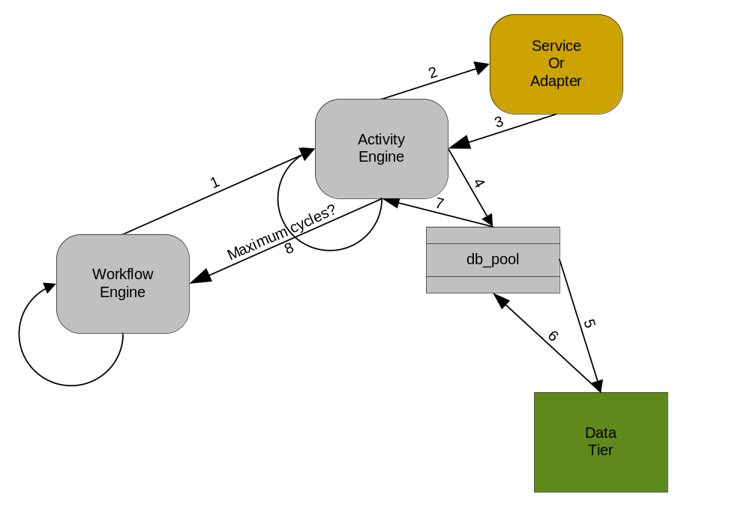

Logging and Error Handling Architecture
GIS provides a detailed audit trail during the entire process flow from session metadata and metrics to the individual process steps taken and their outcome to include before and after File Gateway examples of any data that is transformed. The session logging is viewable through the GIS administration UI in the communications session search screens.

Each unique invocation of a business process contains detailed information for each step taken during processing. Each service or adapter within the BP provides information about the document on which it performed work to include before and after File Gateway document hyperlinks as well as other metadata pertinent to the service or adapter.

Error handling is managed through the use of onFault BPML within individual business processes. The onFault BPML sends a standardized email alert notification to the distribution list identified within a customer cache properties file. The notification email addresses are then available via XPath to the onFault processes.

Sterling Control Center (SCC) also provides alert notification for the GIS node statuses. Unidentified business processes are also configured for external alert notification by SCC.

5.1.3.4 Notification
Notifications are available through both GIS and Sterling Control Center. GIS is able to provide a standardized actionable email alert that indicates various process details. These details are used directly to quickly address the failed process instance. SCC provides a centralized monitoring platform that indicates GIS business process failures through its status dashboard and with a more generalized email alert. Minimally the architecture improves the GIS email alert and standardizes the format to include detailed information within the body of the email and a subject line that indicates the environment and general status escalation levels. This format is common to all GIS business processes.

5.1.3.5 Reporting
Reporting from GIS and SCC include summary level reports and statistics collected during a requested time period. GIS and SCC contain many reports as part of the core product.

Once purchased GIS Visibility/Reporting services add the functionality required to create reports of a statistical nature. Reporting services allow the creating of custom fact models that define the data to be collected. Through the addition of a mapped data step to the relevant business process, data is stored in a fact repository for use by the reports based on the fact models. Reporting services require custom development using Sterling software that allows TDAmeritrade to capture the exact needs for message status reporting. These reports indicate the latest status of message transfers through GIS.

5.1.3.6 Monitoring
Sterling Control Center (SCC) is able to monitor GIS business processes, service and adapter status, and GIS node status. This information is presented in a dashboard fashion within the SCC application. SCC also sends alerts for items identified as critical such as GIS node failure status. These alerts are sent via email and can be configured to send SNMP traps to assist with centralizing operations monitoring.

Configuration of SCC to apply message-specific alerts based on business criticality allows TDAmeritrade to improve the ability of operations to provide higher levels of service to the business units.

5.1.3.7 Data Validation and Transformation
GIS acts only as a file mover. No data is transformed or acted upon in anyway other than file transfer requirements. Future implementations may include introspection of the data file in order to determine routing or for correlation of documents.

5.1.3.8 Clustering
GIS Clustering takes many physical GIS instances turning them into one logical GIS instance (active/active) at the application layer. Each GIS node knows it is part of a cluster. Within each GIS instance, the Central Operations Controller, running in a separate JVM from the GIS application, is aware of not only the other nodes within the cluster, but the capabilities (service configurations) of the nodes. The node on which the Service/Business Process request originated initially handles the request. Requests are potentially directed to the least busy node that is able to provide the needed service.

If any GIS node in the cluster fails, the Central Operations Controller, or “token” node, any ongoing transactions from the failed node are given an “interrupted” status from which a manual resumption is possible on any active node. Depending on the choice made during business process check-in the BP may also automatically resume once identified as interrupted by the BP status process.

All GIS cluster nodes of a given environment point to the same database. GIS nodes are either vertically or horizontally installed. GIS nodes installed on independent servers are installed horizontally. GIS nodes installed to a given server but to different locations on the file system and using different port assignments are installed vertically. It is important when establishing service and adapter configurations that all GIS nodes have access to the same resources that are, ideally, located somewhere other than the GIS servers. For instance, the GIS nodes should access a shared network drive for all file system related accesses. In a Windows environment, the GIS Windows services must login using a domain account in order to access shared network resources.

GIS clustering uses a heartbeat mechanism to identify active nodes. Additionally, one and only one active node holds a token. The token identifies that node as the primary central operations controller. The primary node is responsible for coordinating the cluster and managing node-failure recovery. If the heartbeat of any node is lost the node is marked as suspect until it reestablishes itself with the primary. If the primary becomes suspect, the next active node takes the token and acts as the primary.

This heartbeat mechanism uses the TCP stack of the JGroups multicast protocol. This option allows multicast to occur over TCP/IP using the JGroups java classes that provide a reliable multicast delivery system. Using JGroups multicast improves GIS cluster reliability, especially in high-latency environments.

TDAmeritrade requires the GIS architecture to be, minimally, in a two-node application cluster for high-availability and processing throughput. This installation of GIS uses the TCP/IP JGroups multicast protocol to improve reliability of node status messages between the cluster nodes.

The central operations controller within GIS is able to send atomic units of work to any node in the cluster that has the service or adapter that can process the work. A business process that starts on a given node may be directed by the central ops controller to process a specific unit of work on another node in the event that the originating node becomes too busy.

GIS clusters are highly-scalable. When the capacity of a cluster is reached and the servers are becoming overloaded and taking too long to complete work to meet SLAs the cluster can easily be expanded vertically or horizontally. Increasing the number of nodes is as simple as a new installation of an additional instance of GIS. The new instance is simply pointed to the existing GIS database when installed as a new member of a GIS cluster. Additional Perimeter Servers should also be installed to allow for additional network load-balancing benefits.

Individual nodes may also be tuned to handle specific types of work such as very large files or many small files. The BPs that handle these types of files can be configured to use a mandatory or preferred node concept based on tuning parameters.

The volume and data types at TDAmeritrade indicate a need for tuning all GIS nodes to handle “real-time” data with a moderate payload. Minimally the GIS File Gateway BPs are placed on a higher level queue (queue 8 initially) rather than the default queue 4. Use of the Execution Control service may be warranted as volume peaks are approached. This service allows dynamic queue changes based on message type. Messages that are of a lower priority can be pushed back to a lower-level queue.

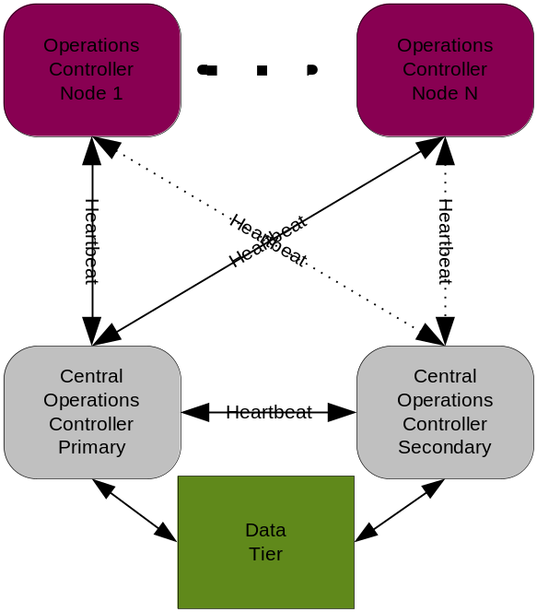

Data Tier – Data Storage Layer Logical Architecture
In this solution GIS is configured to store all data (data files in transit) to the Network Attached Storage (NAS) array. BP metadata (Business Process Workflow data) and GIS configuration information is stored in the database. Data storage can be changed to place data files in transit to the database on an as-needed basis per business processes.

Logging and Error Handling Architecture
GIS logs all interaction with the selected Database Management System. The level of logging is configurable; by default error logging is specified as error only. Errors are logged to the noapp.log file located in the GIS log directory.

The Database Management System (DBMS) provides additional database-specific error handling at the database vendors discretion. The database administrator is responsible for provision of this information.

Physical Architecture

The file transfer implementation for TDAmeritrade includes three physical environments, ITE (Dev/Test), Disaster Recovery (DR), and Production (Prod). All three environments are physically identical with the exception that the Prod environment is replicated to the DR location.

System Physical Architecture
All environments consist of six HP ProLiant BL460c G1 servers. Two servers reside in the DMZ for the installation of the Perimeter Servers, two for the GIS application and Sterling Control Center (one-node only) installations, and two for the Oracle database cluster.

The servers are configured as follows:

- HP ProLiant BL460c G1
- 2 Quad core Xeon processors running at 3GHz
- 2 73.3Gb mirrored hard drives
- 4 Gb RAM

GIS is installed to a two-node application cluster on two separate physical servers in the "CSA Module" of the TDAmeritrade network. There is no clustering other than at the application layer.

The servers residing in the DMZ have two instances of Perimeter Server each, cross-connected to each of the two GIS nodes providing high-availability and load balancing. There are two Perimeter Servers pinned to each GIS node with each PS residing on different DMZ hosts.

There are local Perimeter Servers installed with GIS. Additional local Perimeter Servers are required in order to provide internal load-balancing from the internal network load balancer.

The external Perimeter Servers are fed by a Juniper Network Load Balancer performing Port Address Translation (PAT) in order to spread the inbound load to the exposed PS ports.

The Oracle database is installed on two GIS-dedicated servers in a Veritas cluster.

Sterling Control Center is installed on the GIS node 1 server and to the same database server in a separate schema.

All network modules (CSA, EAG, and SHR) and are granted permissions only for specific ports identified during the configuration of GIS. These ports are yet to be identified, but were discussed and are being decided by the network and OS groups.
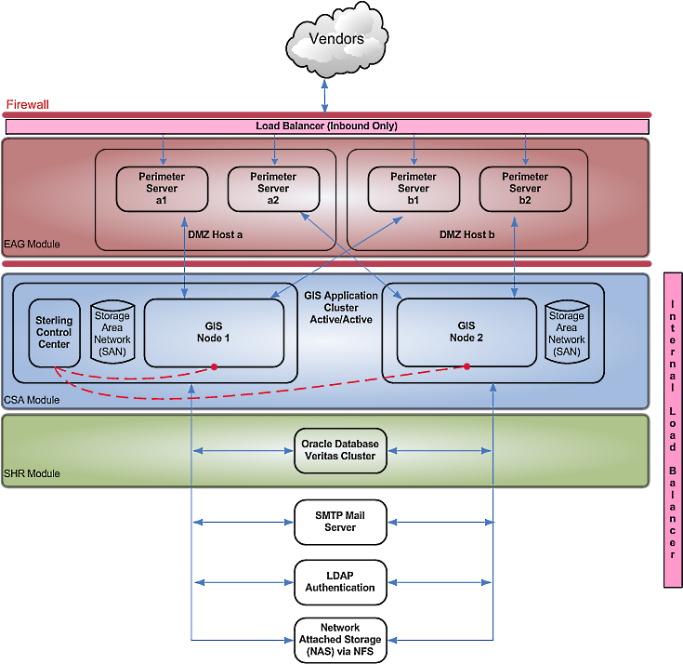

ITE (Test/Dev) environment:

System Component | Host Name | IP Address:Port | Count of CPUs | OS/RAM | Notes
GIS Application  Node 1 | Itejclsgisapp01 | 20,000 | 2x4core  3 GHz | Suse Linux 9 / 4 GB
GIS Application  Node 2 | Itejclsgisapp02 | 20,000 | 2x4core  3 GHz | Suse Linux 9 / 4 GB
GIS Database Node 1 | Itejclsgisdb01 |  | 2x4core  3 GHz | Suse Linux 9 / 4 GB
GIS Database Node 2 | Itejclsgisdb02 |  | 2x4core  3 GHz | Suse Linux 9 / 4 GB
GIS Perimeter Server 1 & 2 | Itejclsgisper01 | 21,000 & 22,000 | 2x4core  3 GHz | Suse Linux 9 / 4 GB
GIS Perimeter Server 3 & 4 | Itejclsgisper02 | 23,000 & 24,000 | 2x4core  3 GHz | Suse Linux 9 / 4 GB
Sterling Control Center | Itejclsgisapp01 |  | 2x4core  3 GHz | Suse Linux 9 / 4 GB

Disaster Recovery (DR) environment:

System Component | Host Name | IP Address:Port | Count of CPUs | OS/RAM | Notes
GIS Application  Node 1 | TBD | 20,000 | 2x4core  3 GHz | Suse Linux 9 / 4 GB
GIS Application  Node 2 | TBD | 20,000 | 2x4core  3 GHz | Suse Linux 9 / 4 GB
GIS Database Node 1 | TBD |  | 2x4core  3 GHz | Suse Linux 9 / 4 GB
GIS Database Node 2 | TBD |  | 2x4core  3 GHz | Suse Linux 9 / 4 GB
GIS Perimeter Server 1 & 2 | TBD | 21,000 & 22,000 | 2x4core  3 GHz | Suse Linux 9 / 4 GB
GIS Perimeter Server 3 & 4 | TBD | 23,000 & 24,000 | 2x4core  3 GHz | Suse Linux 9 / 4 GB
Sterling Control Center | TBD |  | 2x4core  3 GHz | Suse Linux 9 / 4 GB

Production (Prod) environment:

System Component | Host Name | IP Address:Port | Count of CPUs | OS/RAM | Notes
GIS Application  Node 1 | TBD | 20,000 | 2x4core  3 GHz | Suse Linux 9 / 4 GB
GIS Application  Node 2 | TBD | 20,000 | 2x4core  3 GHz | Suse Linux 9 / 4 GB
GIS Database Node 1 | TBD |  | 2x4core  3 GHz | Suse Linux 9 / 4 GB
GIS Database Node 2 | TBD |  | 2x4core  3 GHz | Suse Linux 9 / 4 GB
GIS Perimeter Server 1 & 2 | TBD | 21,000 & 22,000 | 2x4core  3 GHz | Suse Linux 9 / 4 GB
GIS Perimeter Server 3 & 4 | TBD | 23,000 & 24,000 | 2x4core  3 GHz | Suse Linux 9 / 4 GB
Sterling Control Center | TBD |  | 2x4core  3 GHz | Suse Linux 9 / 4 GB

Perimeter Services
The following ports are used for communications exposure to the internal and external network load balancers. There are a total of four external and two internal perimeter server installations per environment. The internal perimeter server installs are in addition to those serving the GIS UI.

Protocol | Port | Host
FTP (command) | 25,021 | All GIS nodes (secondary local PS)
FTP (data) | 25,020 (passive) and 21,100 – 25,200 (active) | All GIS nodes
FTPS | 25,990 | All GIS nodes
FTPS (data) | 25,998 | All GIS nodes
Connect:Direct | 25,364 | All GIS nodes
FTP (command) | 21,021 | PSa1
FTP (data) | 21,020 (passive) and 21,100 – 21,200 (active) | PSa1
FTPS | 21,990 | PSa1
FTPS (data) | 21,998 | PSa1
Connect:Direct | 21,364 | PSa1
FTP (command) | 22,021 | PSa2
FTP (data) | 22,020 (passive) and 21,100 – 22,200 (active) | PSa2
FTPS | 22,990 | PSa2
FTPS (data) | 22,998 | PSa2
Connect:Direct | 22,364 | PSa2
FTP (command) | 23,021 | PSb1
FTP (data) | 23,020 (passive) and 21,100 – 23,200 (active) | PSb1
FTPS | 23,990 | PSb1
FTPS (data) | 23,998 | PSb1
Connect:Direct | 23,364 | PSb1
FTP (command) | 24,021 | PSb2
FTP (data) | 24,020 (passive) and 21,100 – 24,200 (active) | PSb2
FTPS | 24,990 | PSb2
FTPS (data) | 24,998 | PSb2
Connect:Direct | 24,364 | PSb2

The Network Attached Storage (NAS) for document storage is allocated in the following way:

- ITE:
- DR: 1.8 TB
- Prod: 1.8 TB

GIS is installed to the Storage Area Network (SAN) in order to facilitate DR replication and improve high-availability probability.

Disaster Recovery System Physical Architecture
The disaster recovery (DR) architecture is physically the same as the ITE and Production environments. DR is managed through virtual IP addresses on the DR servers. The GIS installation directory and the GIS database schema is replicated (SRDF/A replication) to the DR environment. During activation of the DR protocol the IP addresses on the DR environment are virtualized to match the production environment. Once accomplished, GIS is started and interrupted BPs restarted or resumed based on settings configured during BP check-in.

Process Architecture

This section illustrates data flows through the system and the processes used for the file transfer implementation as designed by this architecture. The details of these individual processes may be outlined in a separate Detailed Design document during implementation.

Solution Definition
This section describes the services applied to this implementation.

Participant Model

All participants retain the control to communicate with GIS using any of the supported communications protocols (FTP, FTPS, C:D). These protocols are presented using the familiar FTP Server directory paradigm. Other interfaces present different views such as the myFile Gateway UI or an FTP graphical client such as FileZilla or FTPPro. WebDAV is also available and presents a UI similar to Windows Explorer in which clients may drag and drop files. The command line approach is scriptable and most often used when communicating with automated systems.

Capacity Management

Document volumes are high in data space volume. The ability of the entire system (Perimeter Servers, GIS, Disk I/O, database I/O) to handle 12,000 messages per day with a data volume of over 600GB is a potential risk. With the expected volume performance testing should be considered during the development phase. Capacity in GIS is managed by adding additional nodes to the GIS application cluster either vertically or horizontally.

Business Process Model

The Business Process Model used in this solution relies on the GIS mailbox framework as well as the File Gateway components to provide ease of on-boarding and automated configuration. The File Gateway framework uses out-of-the-box functionality to provide IP communications protocol support and rules-based file routing within a store-and-forward environment. Files are placed into mailboxes that provide the store-and-forward mechanism similar to an FTP server. The File Gateway router system is triggered upon completed receipt of a file. The router identifies, collects, and processes (routes) the file according to the routing rules established during creation of the Producer/Consumer profiles.

Although none have been identified, any transfers not meeting the out-of-the-box File Gateway functionality require custom protocol (business process) extensions called container or non-container file layers. Container file layers are designed for use with compound files such as .zip and .pgp. Non-container file layers are meant for extra-ordinary file processing or handling outside of that provided during file routing such as file introspection for data typing.

BPs are designed for reuse and maintainability. This is accomplished through the use of dynamic data structures available in a database schema or in a GIS properties file that is cached in memory for ready access.

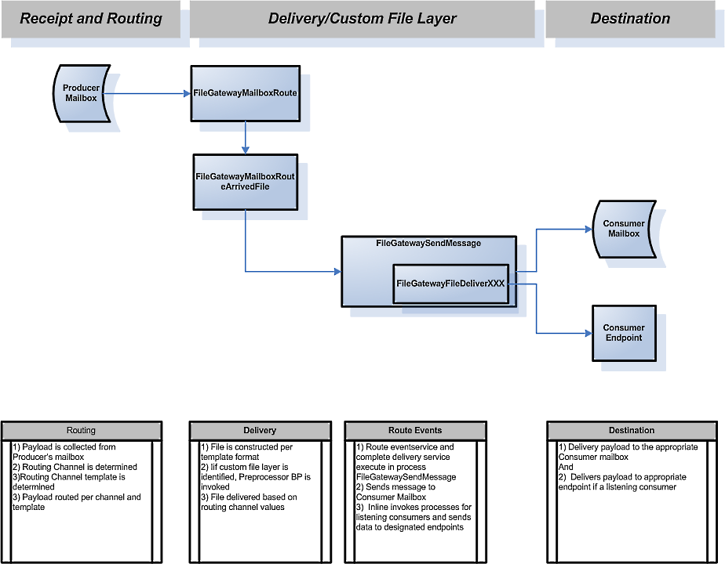

Application Document Types

This solution manages file transfers of many file types, but is responsible for routing only. File types range from plain text, to XML, to PGP encrypted.

Filenames are used extensively in route identification. Most filenames contain a timestamp which may be ignored.

GIS is configured to allow duplicate filenames and to not overwrite.

Business Process Overview
The File Gateway Process Model has five main components: Producer, Routing Channel Template, Routing Channel, routing engine, and Consumer as described below. An additional Community component is simply a structural way of organizing all Producers and Consumers into groups used for reporting.

The TDAmeritrade implementation uses standard File Gateway mechanisms. Outbound files are posted to the Producer mailboxes by the File System Adapter and the associated built-in BP. Inbound files are directly affected by the vendor placing files into the vendor's producer mailbox using one of the identified protocols and are routed using the default File Gateway processes. No customization is identified.

Use of the CEU to GIS migration assets (BaseMFT_Assets) is recommended. This collection of GIS assets eases the on-boarding of File Gateway actors and provides additional functionality such as the tp_config table for use as needed by the process designer. The tp_config table may be leveraged here to store file paths for the outbound files needing collection or for placing inbound files on the file system.

Producer
A Producer is a human or application system that produces data for one or more Consumers. File Gateway supports Producers that push data into GIS using the protocols previously described. The File Gateway Router is triggered upon completion of the document transfer to use the Consumer identification policy configured in the Consumer profiles to identify the recipient(s) of the file. Additional processing such as translation are performed based on profile configuration.

Note: Producer can also be a Consumer.

Note: Custom Business Processes can be built to retrieve data from a Producer that does not have the capability to push the data to GIS. The Business Process would then place the data files into the Producer’s designated directory to enable the Router to finish the distribution as if the Producer had pushed the data to GIS.

Routing Channel Template
The Routing Channel Template specifies producer and consumer mailbox structures and file structures. It functions as a policy that mandates which partners can participate in various file transfer scenarios and which file formats they must use.

Routing Channel
Routing channels match incoming producer files to the appropriate consumer, then transform the file and file name according to the policies of the consumer.

Router
The Router is the core of File Gateway, consisting of a Rules Engine, standard Business Processes, Services and the ability to extend File Gateway functionality with custom processes and rules.

The Routing Channel Templates identify messages placed in a mailbox and execute the main Business Process that activates the Business Rules Engine. Identification of the Consumer is attempted against existing Consumer Profiles. When no matching profile is found, notification required status is checked and a notification sent. Upon identification of the Consumer, processing takes place as needed. Distribution handling is identified in the Consumer policy.

Consumer
Consumer is a human or application system that consumes data from one or more Producers.

Out of the box File Gateway supports Delivery Protocols that push data directly to the Consumer and Delivery Protocols that place the data into the Consumer’s Mailbox for pickup by the Consumer.

Consumers can also be Producers.

Naming Standards
Naming standards are extremely important. Use of a TD_ prefix identifies TDAmeritrade resources and separates them from those preinstalled with GIS.

The following table provides suggested naming standards for the objects created and configured within GIS. This list is not all-inclusive and serves as a representative example only.

Item | Naming Convention | Notes
Business Processes | TD_<Business Process functionality>_BP | Example:  TD_FileSystemCollect_BP
XSLT | TD_<XSLT Name> | Example:  TD_Email_Format
Service Configurations | TD_<Service Name> | Example:  TD_FileSystemAdapter
Maps | TD_<map type>_<doc type> | Example:  TD_XML_to_FlatFile

Archive Strategy and Access

Archiving and purging are used to ensure that disk space limits for the GIS and its database are not exceeded. TDAmeritrade data is retained in active GIS tables for 3-days. Live data files are purged from the File Gateway system after 3-days based on this retention period. This system is not designated as the legal holder for auditing information. BP metadata and the documents themselves are both purged after the 3-day period.

Requirements

Business Requirements

Notification

All failures within GIS send a standardized alert to a distribution list identified in the BP by using the customer cache properties file. SCC adds additional notification when GIS node status changes and when the GIS adapters being monitored change status. The notifications from GIS clearly indicate the environment, BPID, and DTM in the subject line.

Priority file processing
There are priority files within batches of data. During batch processing a large number of files is generated and processed. Certain files within the batch need priority processing. These files are identified by filename and must be processed as soon as they are received and before the other files or concurrently with the initial processing of those files.

Functional Requirements

Protocols
GIS supports all protocol requirements identified by TDAmeritrade. The FTP, FTPS, and Connect:Direct protocols are all directly supported by File Gateway out of the box.

Non-Functional Requirements

Infrastructure

High Availability
GIS is installed as a two-node GIS application cluster. This along with the database cluster and other infrastructure frameworks provide for a highly-available file transfer architecture. All GIS nodes use identical adapters in the event a single node fails. The GIS application cluster also provides load-balancing and creates a true high-availability solution.

Business process design must take into account clustering of the adapters and placement of the adapters into service groups. Additionally, careful consideration must be given to the use of asynchronous business processes for non-essential functions.

Scalability
GIS is configured in a two-node horizontal application cluster on two servers. The GIS application cluster is scalable in both a vertical and horizontal manner. Vertical scaling refers to installing more than one node of GIS within a machine domain. This requires identification of a separate and distinct installation port range and hardware that meets the minimum GIS requirements. Vertical scaling improves use of idle hardware on servers with unused CPUs and RAM.

Horizontal scaling improves high-availability by spreading the cluster across multiple pieces of server hardware. Installation of GIS on the new server using a few cluster-specific parameters allows for easy scaling of GIS to meet increased workload.

Before scaling GIS it is recommended to identify other potential bottlenecks within the file transfer framework such as network, database, and disk I/O.

24/7 Global Operations
Through continued use of the GIS application cluster and highly-available network, database, and disk topologies 24/7 global operations are possible. Newly implemented business processes and assets must account for high-availability and the 24/7 global operations requirements.

Logging/Notification

Logging
GIS maintains a large number of logs specific to each part of the GIS architecture. These logs are available through the GIS administration UI and the GIS install directory in the <GIS install>/logs path.

OnFault Notification
Within GIS notification is controlled through onFault. Indication of notification recipients is collected from the customer cache information stored in RAM and accessed through XPath. The recipients of the notification are all internal personnel.

Additionally, Sterling Control Center rules are configured to send notifications to appropriate recipients based on information contained in the rule configuration.

Training Plan
On site educational requirements are identified for:

- GIS Fundamentals
- Sterling Control Center
- File Gateway

There should also be five-days of knowledge transfer performed by a Sterling consultant that assisted with the implementation that is specific to the TDAmeritrade implementation.

Open Items
Items included in this section are open at this time, and need to be handled before deployment can proceed.

Infrastructure
- Identification of DR and Prod environment names/IP addresses
- Identification of GIS installation base ports
- Identification of protocol ports exposed to the external and internal network load balancers

